**Boundary Traversal of binary tree:-**

Write a function to print Boundary Traversal of a binary tree. Boundary Traversal of a binary tree here means that you have to return **boundary nodes of the binary tree Anti-Clockwise starting from the root**.  
**Note:** Boundary node means nodes present at the boundary of left subtree and nodes present at the right subtree also including leaf nodes.  
For the below tree, the function should print 20 8 4 10 14 25 22 .  
    [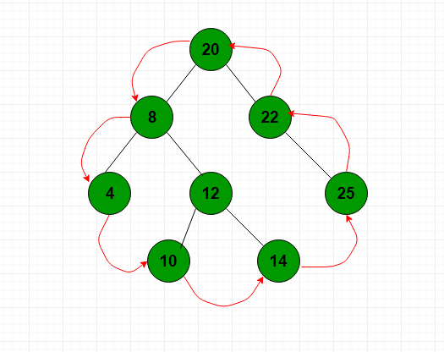](https://contribute.geeksforgeeks.org/wp-content/uploads/boundary.png)

**Example 1:**

**Input:**

1

  / \

  2 3

**Output:** 1 2 3

**Explanation:**

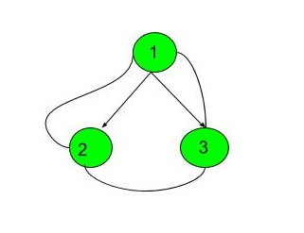

The first test case represents a tree

with 3 nodes and 2 edges where the

root is 1, the left child of 1 is 2

and the right child of 1 is 3. And

boundary traversal of this tree

prints nodes as 1 2 3.

**Example 2:**

**Input:**

  10

  / \

  20 30

  / \

  40 60

**Output:** 10 20 40 60 30

**Your Task:**  
This is a function problem. You don't have to take input. Just complete the **function printBoundary()**that takes the root nodeas inputand returns an array containing the boundary values in anti-clockwise.

**Expected Time Complexity:** O(N).   
**Expected Auxiliary Space:** O(Height of the Tree).

**Constraints:**  
1 <= Number of nodes<= 105  
1 <= Data of a node<= 105